Supply chain network design to support biofuel production: A case study

**NOTE**:

1. The due date for this case study is the last day of classes, Dec. 6th, 8pm.
2. We will schedule a meeting together so you can run the model for me and explain the code. These meetings will happen on Friday, Dec. 7th.
3. You can gain up to 5 points in this assignment. That means, if your total points in the class at the end of the semester are 90. Then, your total becomes 95 if you were to complete this assignment. These points can make a difference in your grade.
4. You will need to submit two files to complete this case study.
5. Julia files you have built to solve the problem.
6. A “.docx” file which presents the model you have developed and the results of the analysis.

This report should provide: (i) the total cost of the supply chain; (ii) the values of the different variables you have defined (e.g., the values of Xij variables).

Problem Statement

The company XYZ has decided to produce bioethanol in the state of Texas. The company needs to design a supply chain consisting of suppliers, hubs and biorefineries for the conversion of raw material (i.e., biomass) into biofuel. The suppliers of biomass are represented by the counties in the state of Texas; it is assumed that the centroid of the county is the county seat. A total of 254 counties (see Table 1) are available to supply the necessary feedstock for the production process. The supply information is provided in the file TX_suppliers.csv.

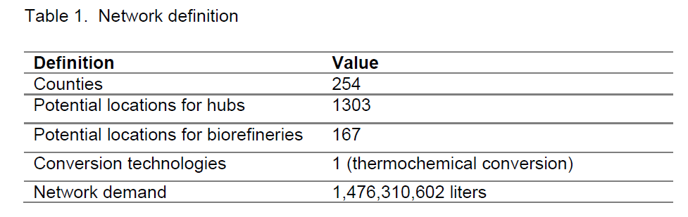

Hubs are needed to consolidate and preprocess biomass to reduce the transportation cost and, therefore, the delivery cost as well as to meet the biomass quality characteristics. The potential locations to open hubs correspond to train stations (see file TX_hubs.csv for locations) because the transportation mode utilized to move the raw material from the hubs to the biorefineries is train. The distances (km) and transportation costs ($/ton) are included in file TX_railroads.csv. The cost of loading/unloading on a train route is $3,066,792 USD/ year and its capacity is 338,000 Mg. The hubs serve as transshipment and preprocessing node, no storage of material is allowed.

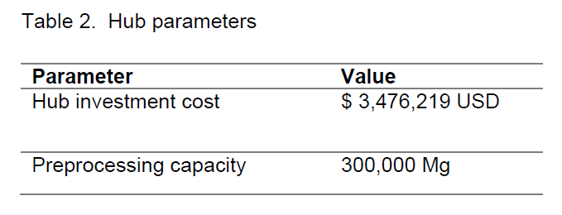

Truck is the transportation mode utilized to move the biomass from the counties to the hubs. The distances (km) and transportation costs ($/ton) are presented in file TX_roads.csv. The investment cost to build a hub is shown in Table 2. The set of potential locations to open the hubs has several locations too close to each other; thus, a reduction in the number of potential locations is appropriate. The potential locations to open the biorefineries are obtained from feasibility studies conducted by government agencies. The potential biorefineries’ coordinates are in file TX_plants.csv. Different biomass conversion technologies can be implemented in the biorefineries. The technology considered for the conversion process in this case study is the thermochemical conversion. The cost to open a biorefinery is presented in Table 3.

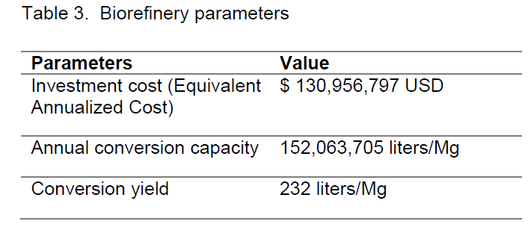

The bioethanol demand for the state must be satisfied by production at the biorefineries. The demand is assumed deterministic.

The goal of the problem is to minimize the investment and transportation costs by finding the optimal number of hubs and biorefineries that the company needs to invest on, as well as ,the flows between suppliers-hubs and hubs-biorefineries. The company asks IEs to model and solve this problem**.**